Hello teacher. Here's the story about bullying. I hope you like XD.

School: Enrique Olaya herrera

Members: David velandia -Nicolás urrego.

Cursé: 906

Teacher : Iván potier

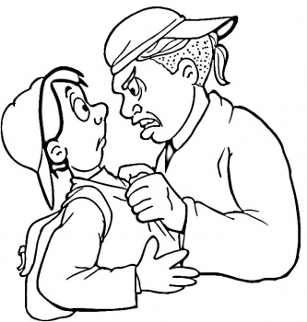 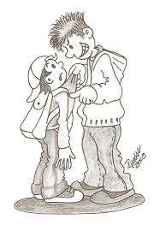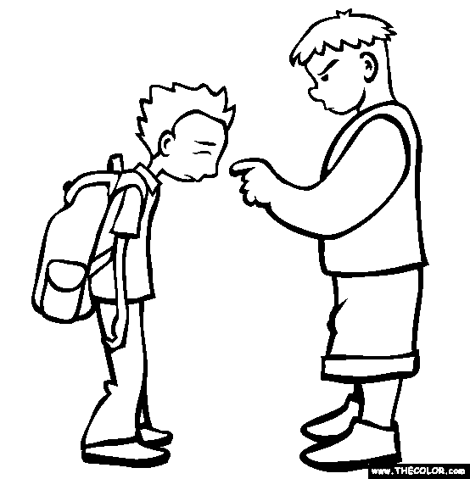 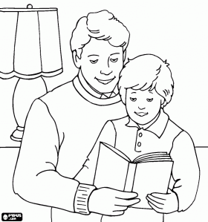

If you ever hit that boy you get in trouble.

I warn you tomorrow I want money if you do not hit.

So this guy hits you. I will tell Orlando to talk to.

As I was child.

I was a bad father. A guy hit me and said he will take my money.

That's wrong

